Fraud Detection Architecture & Implementation

1. Project Overview
The Fraud Detection System is designed as an end-to-end intelligent pipeline that identifies suspicious financial transactions using machine learning techniques. Unlike traditional rule-based systems, which rely on fixed thresholds and predefined logic, this system leverages unsupervised anomaly detection to dynamically identify unusual behavior patterns.
The core objective of the system is to:
- Detect fraudulent transactions in near real-time
- Adapt to evolving fraud patterns without manual rule updates
- Reduce false positives while maintaining high detection accuracy
- Automate monitoring and reporting for operational efficiency
The system uses the Isolation Forest algorithm, which is particularly effective in detecting anomalies in large datasets where fraudulent transactions are rare and distinct from normal behaviour.

2. Operational Workflow
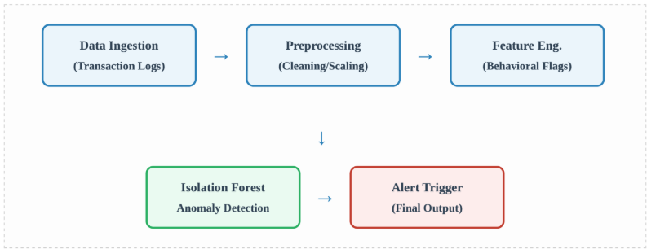

Step 1: Data Ingestion
- Source: Transaction logs (CSV / database / APIs)
- Includes:
  - Transaction amount
  - Timestamp
  - Account details
  - Login attempts
  - Device/IP info
Goal:
Ensure continuous inflow of latest transaction data

Step 2: Data Preprocessing
Key operations:
- Convert TransactionDate to datetime format
- Sort transactions by: AccountID + TransactionDate
- Handle missing values
- Remove inconsistencies

NOTE: Details about further steps in workflow are given below in detail.

3. Feature Engineering Analysis
To improve model accuracy, we've implemented specific behavioral features that serve as indicators of high-risk activity. These features focus on velocity, volume, and authentication patterns
The following are the patterns where the Logic is applied and the value is Detected:
Logic Applied | Detection Value
Rapid Transactions | Identifies automated bot behavior.
High Login Attempts | Flags potential brute-force or account  takeover.
Top 10% Amount | Monitors high-exposure transactions.
LogTime Diff | Analyzes the cadence of user activity.

NOTE: While individual features like "High Amount" may not be fraudulent on their own, the isolation forest algorithm looks for the unique combination of these features that sets a transaction apart from the norm.

4. Model Logic: The Isolation Forest
Unlike traditional clustering which groups "normal" data, Isolation Forest explicitly seeks to isolate anomalies. Because fraudulent data points are "few and different," they are isolated closer to the root of the decision trees

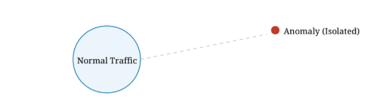
The model outputs a score where -1 indicates a confirmed anomaly and 1 indicates normal behavior
🔹 Core Concept
Isolation Forest works on a simple idea:
“Anomalies are easier to isolate than normal points”
🔹 How it works
- Randomly select a feature
- Randomly split data
- Repeat recursively
- Measure path length
🔹 Key Insight
- Normal data - deeper tree
- Fraud data - isolated quickly
🔹 Output
- 1 → Fraud (Anomaly)
1 → Normal
🔹 Why Isolation Forest?
- Works without labeled data
- Handles large datasets efficiently
- Detects unknown fraud patterns

5. Continuous Automation
The system is not a one-time analysis tool but an automated operational pipeline. It runs daily ingestion tasks and automatically generates summary reports in Excel format for our compliance team.
- Daily Ingestion: Refreshes the dataset with the latest 24 hours of logs.
- Automated Pipeline: Runs feature engineering and model scoring without manual triggers
- Alerting: Sends immediate notifications if the system identifies high-confidence fraud.
🔹 Objective
Convert system from: Manual analysis To Automated daily monitoring
🔹 Automation Tasks
Task 1: Daily Data Ingestion
- Load latest transaction file
- Append or replace dataset
Task 2: Automated Model Execution
- No manual intervention
- Runs entire pipeline
Task 3: Report Generation
Outputs:
- fraud_report.xlsx → fraud transactions
- summary_report.xlsx → stats
Task 4: Alert System
Trigger when:
fraud_count > 0
Alert methods:
- Console alerts
- Email alerts
- Dashboard notifications

6. Dashboard & Visualization
🔹 Purpose
- Enable fraud investigation
- Provide interactive analysis
🔹 Features
- Filter by:
  - Transaction amount
  - Login attempts
  - Time difference
- Interactive charts:
  - Scatter plot (fraud patterns)
  - Histogram (distribution)
  - Bar chart (top anomalies)

7. Testing & Validation
🔹 Validation Methods
1. Statistical Validation
df.groupby('Fraud').mean()
Fraud should show:
- Higher login attempts
- Different time behavior
2. Synthetic Testing
Create fake fraud:
High amount + multiple logins + fast transaction
Should be flagged
3. Output Validation
Check:
- Excel reports
- Dashboard output
- Alerts

8. Conclusion
This system demonstrates a complete fraud detection lifecycle, integrating data engineering, machine learning, automation, and visualization into a unified pipeline.
By leveraging Isolation Forest, the system focuses on identifying anomalies rather than predefined rules, making it robust against evolving fraud techniques.
The addition of automation and reporting ensures continuous monitoring, while the dashboard enables interactive investigation, making the system both operationally efficient and analytically powerful.

